THE ECOLOGICAL VALUES

OF

MOUNT CARDRONA STATION –

RUN 3 LODGE SITE

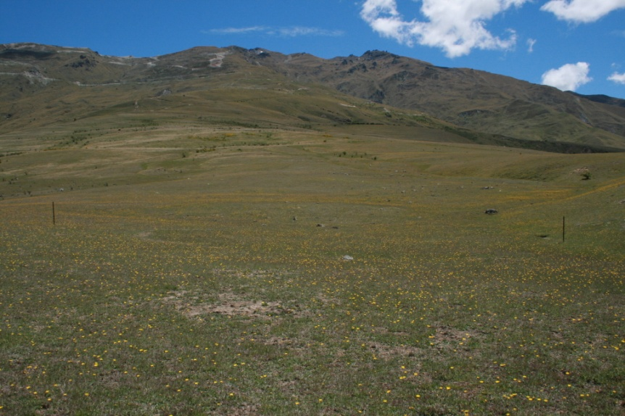

View uphill from proposed Lodge site

**February 2018**

## N C Simpson

**Conservation Consultancy Limited**

**181 Peninsula Rd., Kawarau Falls**

**QUEENSTOWN 9300**

THE ECOLOGICAL VALUES OF MOUNT CARDRONA STATION – RUN 3 LODGE SITE

INTRODUCTION

Mount Cardrona Station has proposed a luxury lodge and ancillary buildings at the southern end of their property, an area of 168 ha called Run 3. The proposed development consists of a lodge, several mutterers’ style huts and an access road. A small tarn will also be created in front of the lodge.

An ecological survey of Run 3 was undertaken by Conservation Consultancy Ltd in December 2017 the results of which are reported here.

**TOPOGRAPHY**

Run 3 descends from the Cardrona Ski field road at about 1300 m initially down moderate hill slopes then fanning out onto broad, gently sloping, terrace country contained on the south side by Little Meg stream and to the north by Pongs Creek. Several small, shallow, generally dry, channels run down this terrace to where it flattens out at about 700 m near where the proposed lodge site is. A spring forms a small wetland just above the terrace scarp where it steepens towards the Cardrona Valley Road. The access road to the lodge comes up beside this wetland. There are a number of small seepages on the upper part of this scarp slope on the north side of the road with associated wetlands that join down slope to form small streams. Refer photo below.

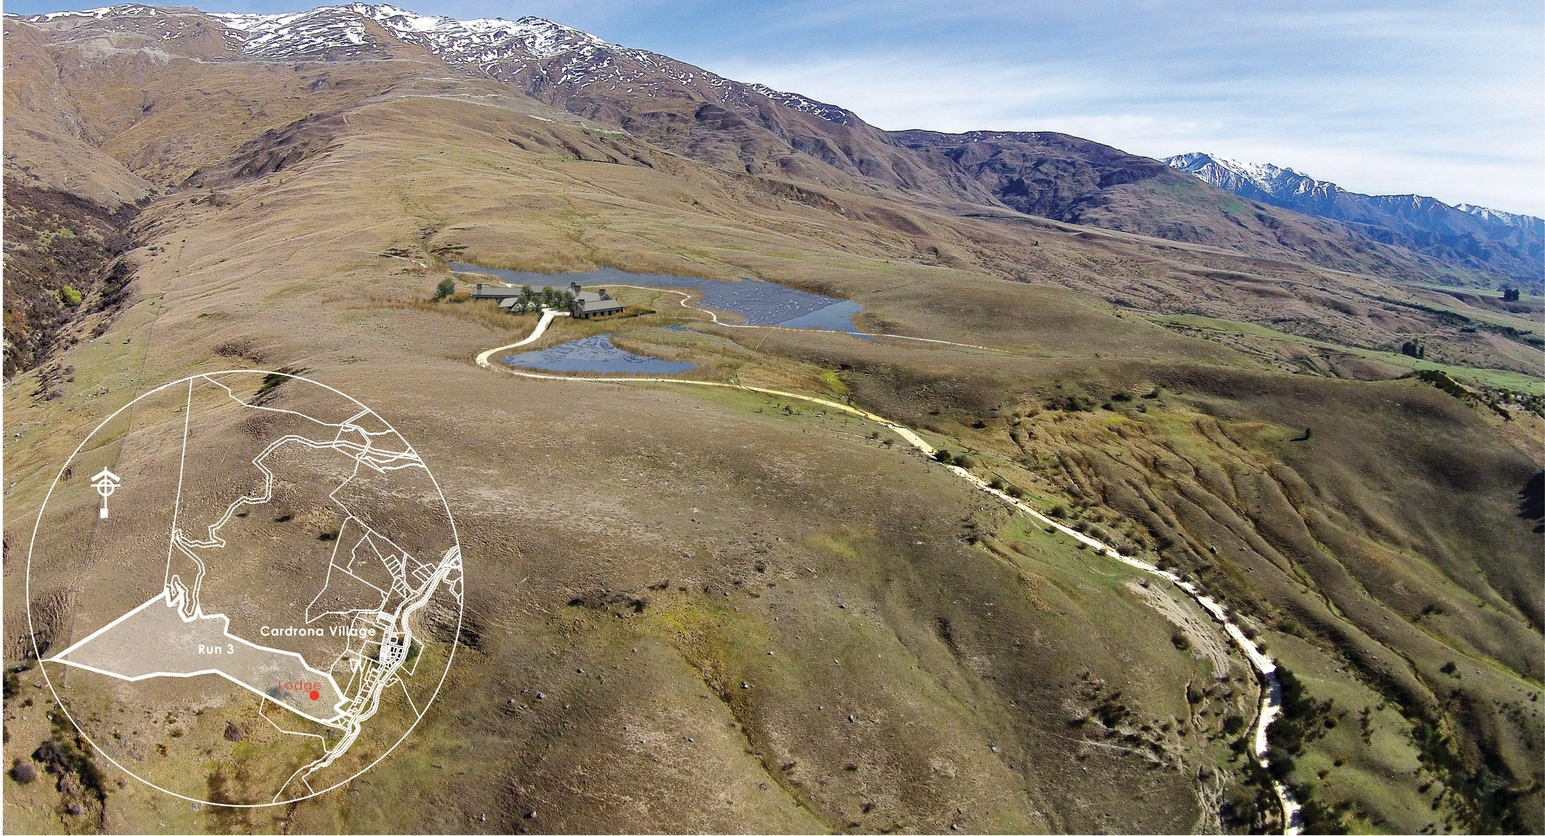

VEGETATION

Indications are that the pre-human vegetation in this area was a closed forest of native broadleaved species with also beech forest and small wetland communities. Grey shrubland and kanuka with small areas of native grassland would also have been present with tall tussockland at higher altitudes.

Although little remains of the original plant species, there is still the potential to partially restore some of the natural ecological systems and plant communities.

Present Vegetation

Most of the Mt. Cardrona Station land contained within the study area is pastureland composed of exotic grassland with much mouse ear hawkweed (Pilosella officinarum). Scattered matagouri bushes (Discaria toumatou), porcupine bush (*Melicytus* alpinus), sweet briar (Rubus rubiginosa) and patches of broom (Cytisus scoparius) are present on the mid slopes and higher areas and in the deeper gullies. Rabbits are numerous.

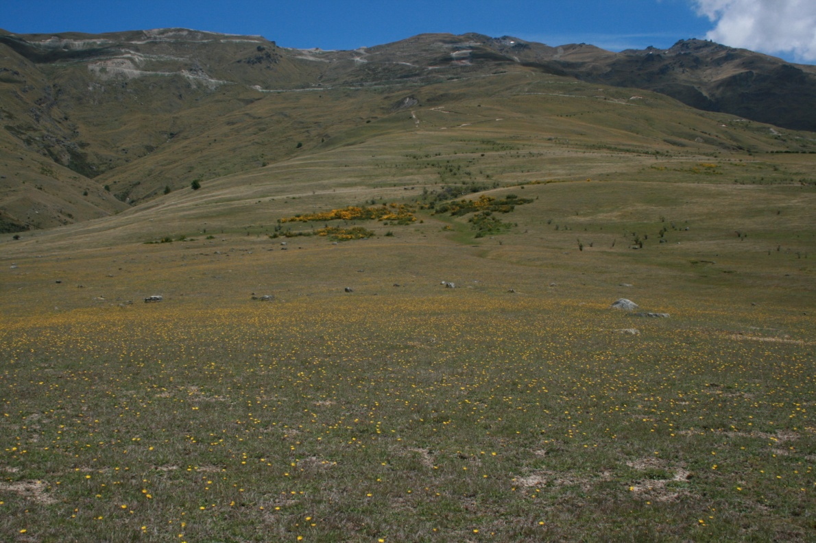

Pasture land with much bare ground and dense mouse ear hawkweed, yellow flowers,

flowering broom mid slope and scattered brier and matagouri.

At about 1200 m native species become prominent with snow tussock (*Chionochloa rigida*), hard tussock (*Festuca novae-zelandiae*), blue tussock (*Poa colensoi*), *Rytidosperma pumila,* a few small herbs such as harebell (*Wahlenbergia albomarginata*), native violet (*Viola cunninghamii*), *Celmisia gracilenta,* a mat plant (*Raoulia subsericea*)*,* the everlasting daisy *(Anaphalioides bellidioides*), a native carrot *Anisotome flexuosus*  and several small shrubs including patotara (*Leucopogon fraseri*)*,* small heaths (*Gaultheria parvula* and *Gaultheria depressa var. novae-zelandiae*)*,*native daphne(*Pimelea oreophylla*)*, Dracophyllum rosmarinifolium* and *Coprosma petriei.* The small fern *Blechnum penna marina* occurs and the rush *Luzula rufa* together withseveral mosses and lichens and common exotic grasses and herbs that are found on most of the property.

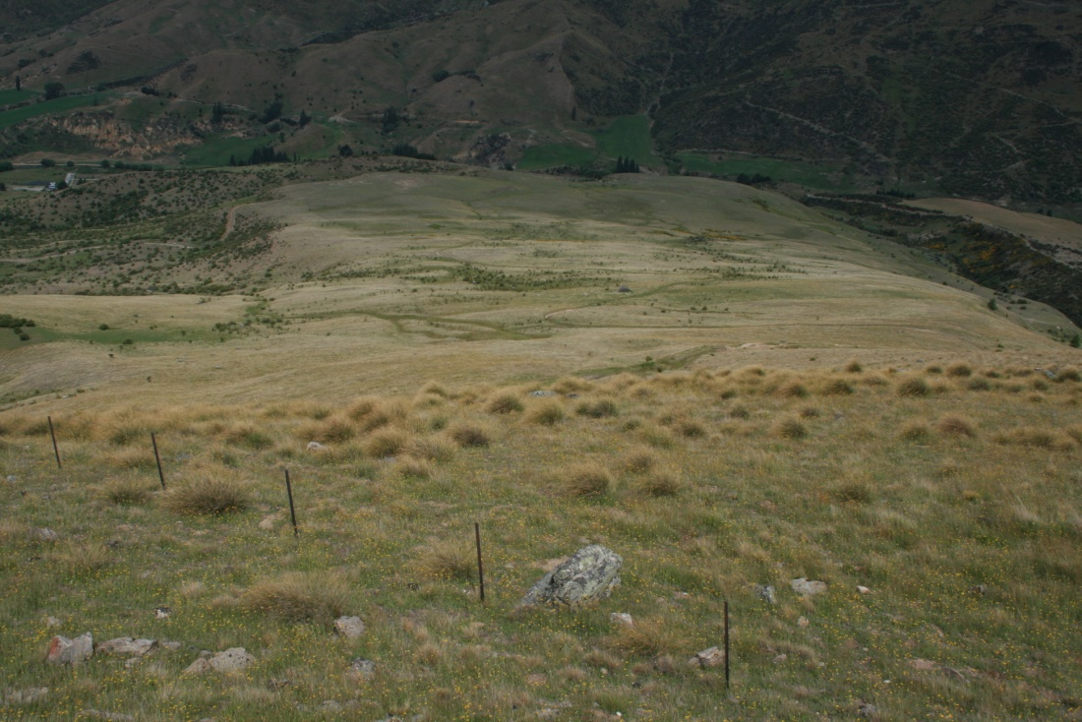

**Top of Run 3 looking down to the proposed lodge site showing snow tussock**

**Vegetation in the foreground.**

##### Lower Wetlands

Wetlands are one of New Zealand’s most endangered habitats with less than 10% remaining. The small wetland found just below the proposed lodge site and to the right (north) of the access road is the most intact native community on Run 3 and so is important. Here a spring rises from the foot of a low terrace to flow into a medium sized wetland or domed (or raised) bog with much sphagnum moss (*Sphagnum cristatum*) and rautahi (*Carex coriacea*). The wetland extends some distance down slope before narrowing to form a small stream but widens lower to coalesce with the numerous rivulets flowing from springs along the top of the scarp to the north. The most important part is the raised bog that appears to be quite natural, which is unusual where grazing animals are or have been present.

The wetland contains many native species and few exotic species. As well as the sphagnum and rautahi mentioned, there are two orchids (*Thelymitra uniflora, Prasophyllum colensoi*) and a number of native herbs, rushes and sedges including *Hydrocotyle montana,* *Gonocarpus micranthus, Lobelia angulata, Gaultheria parvula, Hypericum sp., Celmisia gracilenta, Luzula leptophylla, Luzula rufa* the comb sedge (*Oreobolus pectinatus*), *Isolepis aucklandicus, Carex echinata, Carex gaudichaudiana, Plantago uniflora, Epilobium komarovianum, Epilobium brunescens, Epilobium alsinoides, Euchiton laterale,* the buttercups *Ranunculus multiscapus, Ranunculus royi* and *Ranunculus glabrifolius.* Mosses and liverworts are common.

The few exotic species include *Juncus articulatus, Juncus effusus,* selfheal (*Prunella vulgaris*), musk (*Mimulus moschatus*), Kentucky blue grass (*Poa pratense*), gentian (*Centaurium erythraea*), Yorkshire fog (*Holcus lanatus)* and sweet vernal (*Anthoxanthum odoratum*).

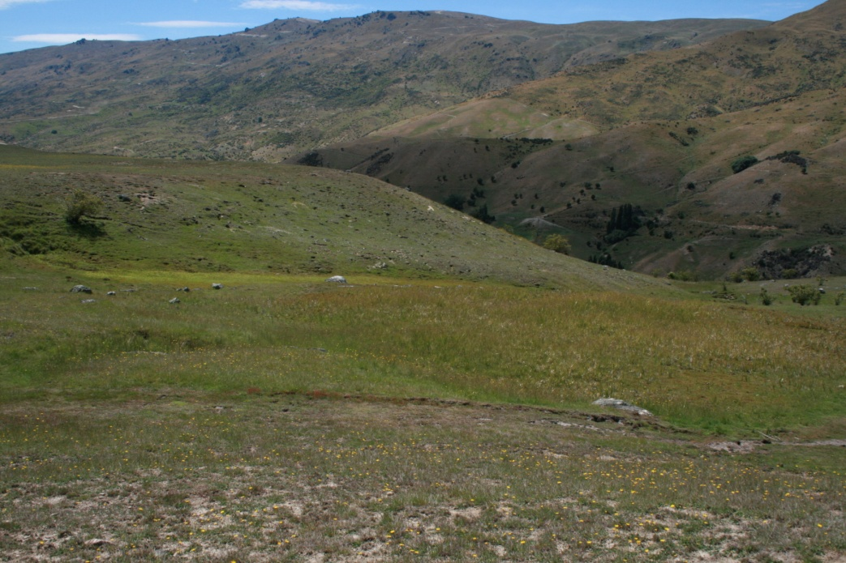

Foreground shows poor pasture with much bare ground and dominant

mouse ear hawkweed with the raised bog centre and wetland behind

emerging from the bank at the extreme left.

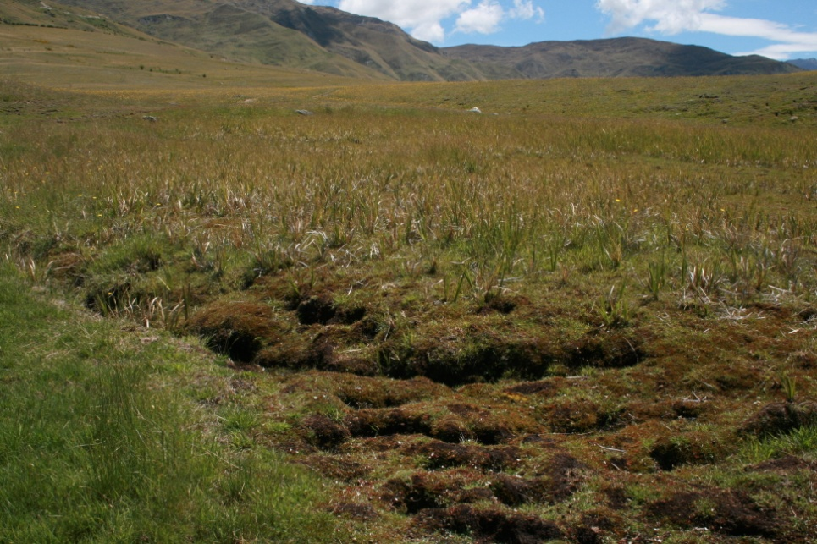

View of raised bog from below showing dominant sphagnum

moss with grassy looking sedge, rautahi.

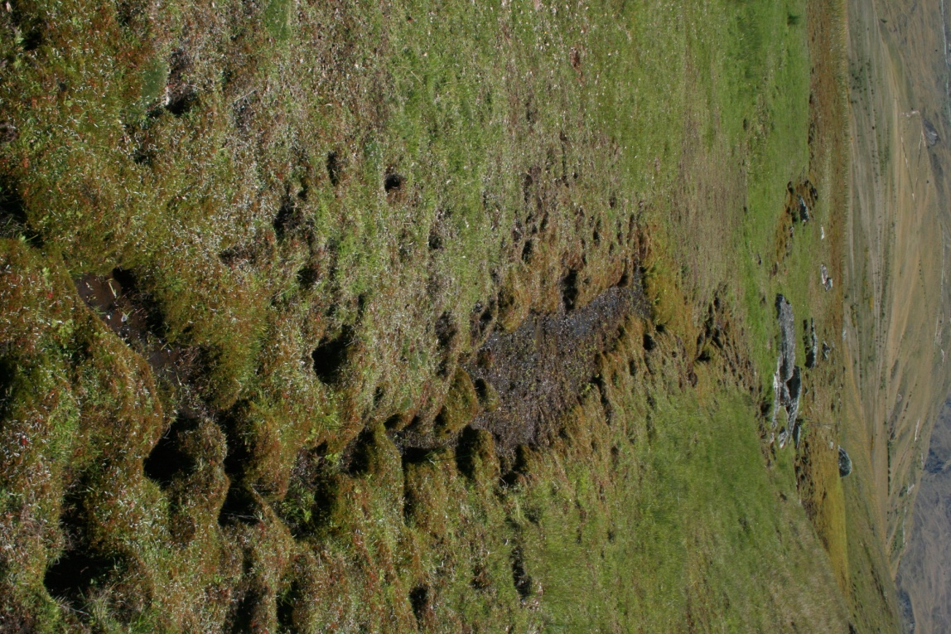 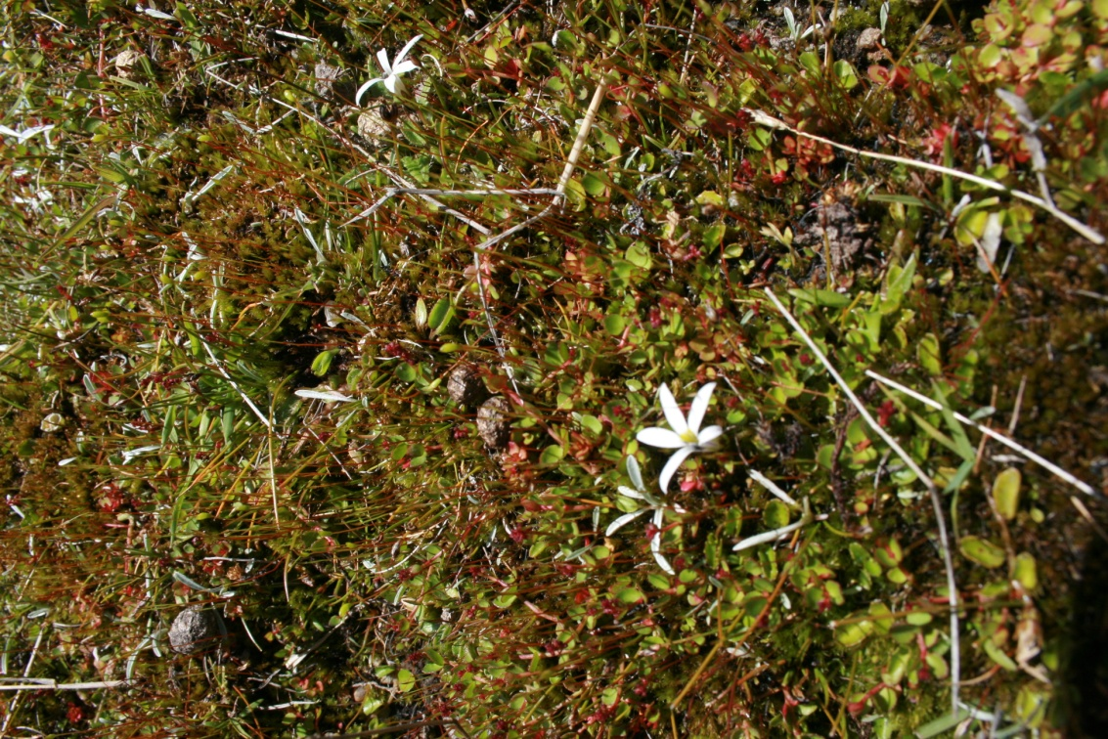 Wetland from below showing raised bog section Close up of *Lobelia angulata*, white flower with upper left adjoining the seepage area right and red tips of *Gonocarpus micranthus.*  stream in the foreground.

ECOLOGICAL VALUES

Few natural values remain on the lower terrace country of Mt. Cardrona Station, below about 800 m. The vegetation is primarily of introduced grasses and other exotic species. It appears to be degraded farmland with numerous rabbits present. On Run 3 there is much bare ground and on the broad ridges and dry terrace country in particular, the unpalatable mouse ear hawkweed dominates.

Matagouri is scattered across the landscape with occasional porcupine shrubs with a few Coprosma propinqua in gullies. The bird population is primarily introduced with Pipit and Harrier hawk and visitors such the Paradise duck the exceptions. The invertebrate population is not known but the lizard population is indigenous. So the ecological values are generally low with no known important, rare or endangered species present. The boulders and porcupine shrub can be important for lizards, the former as a heat source and the latter for its protective cover and fruit.

On Run 3 the domed bog and associated wetland does have high ecological values. This wetland has good diversity with a range of native species and few exotic plants.

Domed bogs are described in Johnson and Gerbeaux (2004) as “One of the classic forms created by natural wetland processes….where peat has grown deepest in the most poorly drained centre, resulting in a convex surface that rises above the local topography and becomes progressively more isolated from inputs of nutrients from either underlying mineral substrate or the surrounding land.

It is important that this wetland should be protected from any disturbance from the proposed development. Possible threats from changed drainage patterns or from silting should be carefully managed through the development. The proposed development presents an opportunity for further protection and enhancement of the wetland by excluding stock and traffic access.

THE PROPOSED DEVELOPMENT

The site of the proposed Lodge and ponds on the north side appear to be good use of this degraded farmland with no or minimal ecological values. Judicious planting with native plants around the building and ponds would significantly improve the ecological values, provide habitat for native fauna and invertebrates and provide a sort of oasis on this bare ridge top. Some planting could extend up one or two of the shallow channels or gullies that run uphill from the lodge site.

The lower or east pond shown on the plan would need to be kept separate from the wetland and any overland drainage kept out of the wetland to preserve its integrity and its drainage system. A raised water table in the near vicinity of the wetland if carefully planted could also enhance and add to the wetland system.

The access road is shown as passing close to the wetland and this could have the effect of allowing runoff off the road to change the natural drainage system and also add siltation to the detriment of the plants. There appears to be plenty of scope to ensure that this road keeps well away from the wetland.

The musterer’s huts plan to be sited along the upper edge of the valley edge (true left) of the Little Meg. There is good matagouri shrubland in the lower valley with scattered shrubs higher. Natural regeneration will occur here over time particularly if stock pressure is light but planting around the musterer huts would increase the natural habitat, introduce other native species that have disappeared from this area, speed up regeneration and provide some screening for the huts.

ECOLOGICAL ENHANCEMENT

There is scope for ecological planting to be carried out in conjunction with the proposed development that would significantly improve the ecology of Run 3 and the wetland surrounds. Planting small groups of native trees and shrubs in suitable places around the lodge would help tie into the otherwise bare landscape with presently low ecological values. Indigenous planting around the proposed musterer’s huts in particular would blend in with existing sparse shrubland vegetation in this area and improve the diversity and the native seed source for the area. As the plants matured over time the bird population would increase and aid natural regeneration.

Suggested Indigenous Planting

This project has the potential to enhance this depleted land and the proposed development by the planting of indigenous plants. This landscape would at one time have been covered in woody vegetation, probably beech forest. Only a few remnants now remain and the seed source lost. The judicious planting of native plants around the planned buildings with groups of plants in the shallow gullies and around the wetland would improve the area ecologically and it’s biodiversity.

Musterer Huts

Build on any existing vegetation by planting groups of plants, mainly shrubs that will grow to three to four meters in height plus groups of mountain beech. Suggest about 100 to 150 plants for each building.

Shallow Gully Systems

There are a number of these shallow gullies or swales that wind down slope. They are damper places than the surrounding land and already contain a scattering of plants mainly matagouri.

These gullies could be planted with groups of shrubs that were/are typical of this region and were at one time likely to have been found growing here naturally. This could connect with the Musterer hut plantings and the proposed Lodge not only enhance the ecology/biodiversity of this area but also add interest to a rather bare landscape. The indigenous plants would in time attract native birds and insects and possibly lizards and provide a seed source for natural regeneration to take place.

To fill such an area would take tens of thousands of plants but it is suggested that a number of groups of about 250 plants scattered along the gullies would make quite an impression and significantly enhance the ecology of this site. Twenty groups would give 5000 plants but these would be widely spaced so more planted over several years would be much more effective.

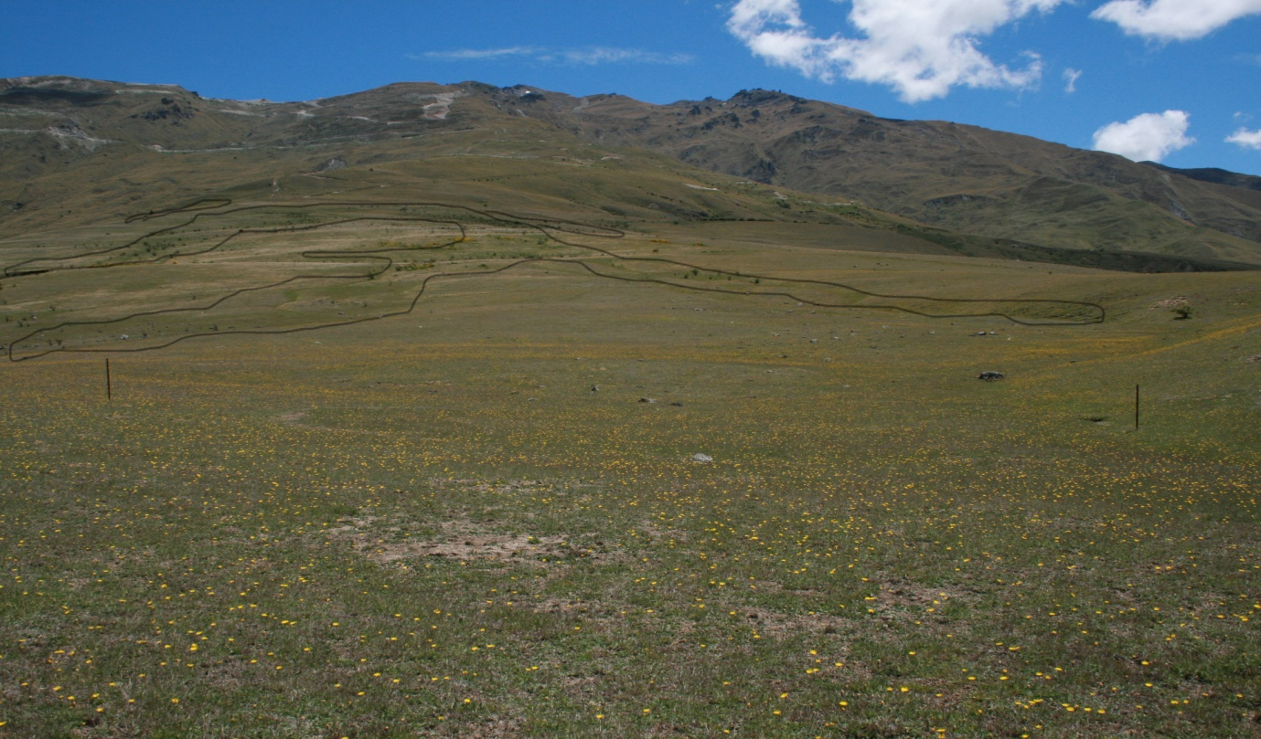

Photo 1. View from the approximate Lodge site showing the shallow gullies and swales referred to above showing the proximity of the Musterer Huts upper left along the ridge.

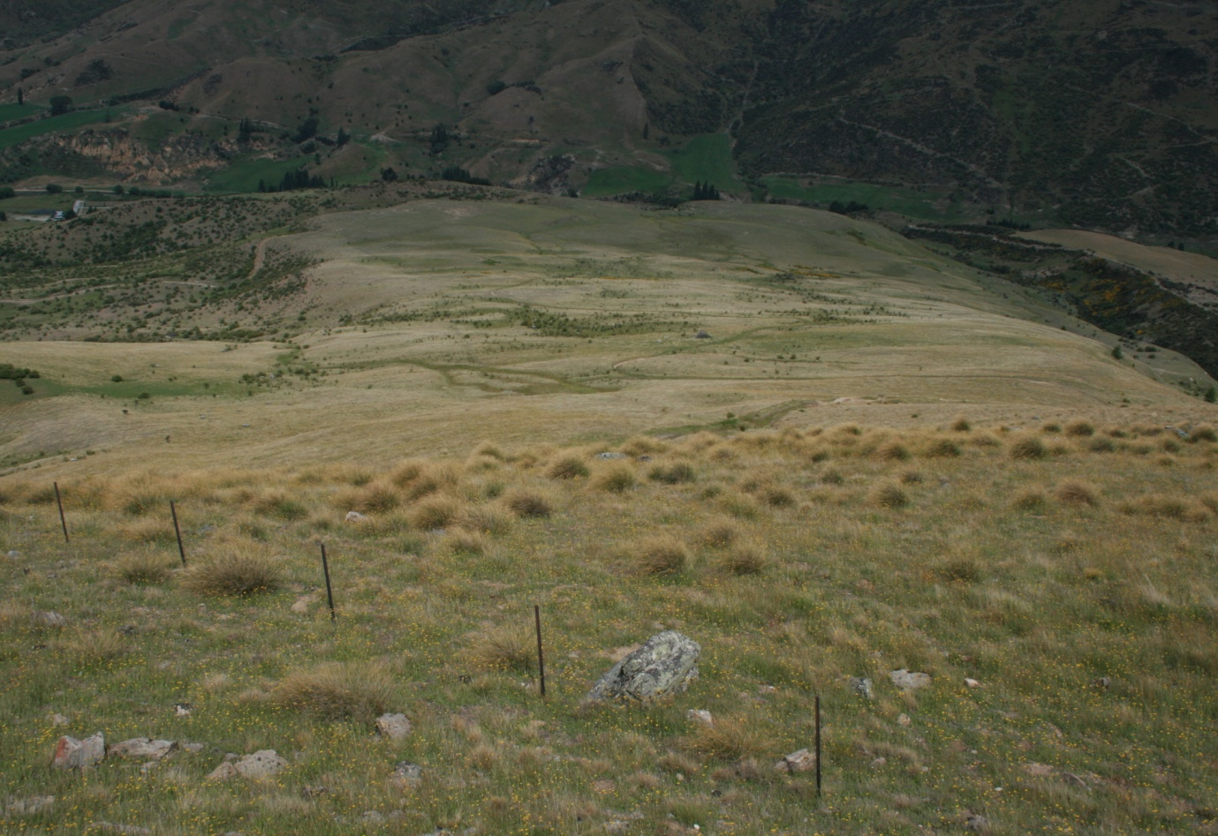

Photo 2. View down from below the skifield road towards the lodge site showing gullies as green areas with shrubs.

Lodge Site

Similar plant species could be planted in smaller groups around the lodge.

Wetland

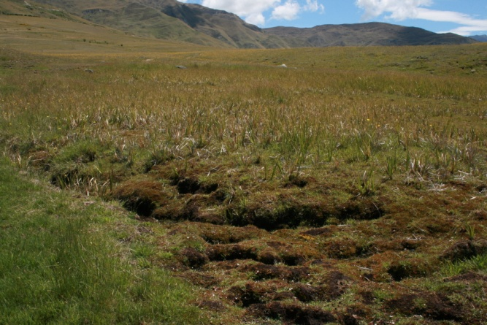 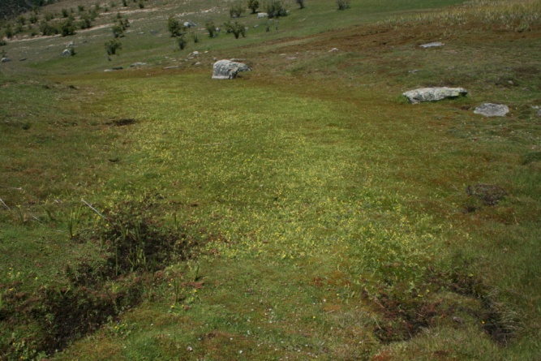

Photo 3. Large raised bog with native sedges and moss. Photo 4. Seepage with raised bog upper right.

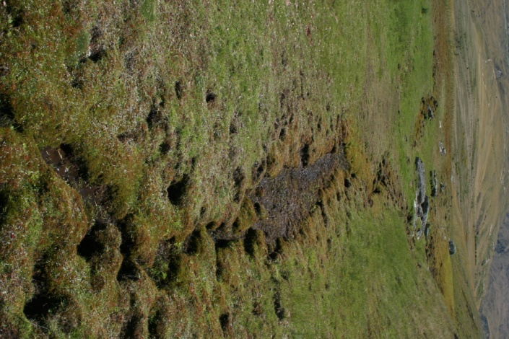

Photo 5. View back up streamlet to raised bog at upper left and seepage upper right.

The wetland is a very sensitive area and probably best left as is. Some protection of the raised bog could be undertaken by planting an irregular band of copper (red) tussock (*Chionochloa rubra*) on the upper and south sides and parts of the south sides of the seepage and the streamlet primarily to limit access and delineate these places otherwise disturbance is not recommended.

A list of suitable plants for each area follows, plants that should be successful at this site and that would have been found in this area at one time.

|  |  |  |  |  |  |
| --- | --- | --- | --- | --- | --- |
| **Plant lists for Cardrona Run 3** | | | | | |
|
| **Species** | **Common Name** | **Huts** | **Gully** | **Lodge** | **wetland** |
| Austroderia richardii | toitoi |  |  |  | 20 |
| Chionochloa rubra | red tussock |  |  |  | 60 |
| Coprosma crassifolius |  | 10 |  |  |  |
| Coprosma propinqua |  | 10 | 15 |  | 10 |
| Coprosma rigida |  |  | 5 |  |  |
| Coprosma virescens |  | 10 | 10 | 10 |  |
| Corokia cotoneaster | korokia | 10 | 10 | 10 |  |
| Fuscospora cliffortioides | mountain beech | 20 |  | 20 |  |
| Hebe salicifolia | koromiko |  | 10 |  |  |
| Leptospermum scoparium | manuka | 20 | 20 | 10 |  |
| Olearia bullata |  |  | 5 |  | 5 |
| Olearia lineata |  | 10 | 10 | 10 | 5 |
| Olearia odorata |  | 10 | 10 | 10 |  |
| Phormium cookianum | mountain flax |  |  | 10 |  |
| Pittosporum tenuifolium | kohuhu |  |  | 5 |  |
| Podocarpus laetus | mountain totara |  | 5 | 5 |  |
| Sophora microphylla | kowhai |  |  | 10 |  |
| * column figures refer to % of 100 not plant numbers | | | | | |
| Totals % |  | 100 | 100 | 100 | 100 |
|  |  |  |  |  |  |

Scarp Face

No consideration was given to the possible enhancement of the scarp face below the Lodge site but this also has potential for ecological enhancement by using a similar mix of plants as for the gully planting. This face appears to be damper than higher up so any planting should be successful.

General Planting Information

* In some areas planting can take place in early autumn if the ground is damp or plants are well watered in. But the best time in the Wakatipu is generally from late August through to the beginning of November. Later planting is possible if on a watering system.
* It is better to plant a smaller area densely than to try to cover a larger area thinly.
* Planting in groups is recommended with trees planted at about 2 m apart and shrubs as close as 1 m. The close spacing helps suppress weeds, provides mutual support and shelter.
* Plants should be planted slightly deeper than the existing soil surface so that a shallow depression is left around the plant to ensure that water reaches the new roots and on steeper hill slopes a small platform is required so that water does not just run off.
* Plants should be watered in as planted unless the soil is very wet. South and east facing slopes can be more successful than north and west facing areas that get the full effect of afternoon sun and therefore dry out more readily.
* Gully bottoms are also good places to plant as they receive more moisture and therefore remain damp longer than hill slopes.
* Including a slow release fertiliser with each plant will give them an initial boost.
* Cool, overcast days are best for planting. On hot sunny days care needs to be taken to ensure that plants are not left in the sunlight with their roots exposed so that they dry out. Drying of the root ball will at the very least set back the plant growth and may lead to it dying.

It is recommended that for planting on Run 3 larger size plants (PB2/3 or PB5) should be used rather than smaller, cheaper root trainer (V150 or similar size) plants that will dry out more quickly if dry conditions occur.

Protection

Animal pests, especially rabbits but also hares, goats and deer, can cause losses of newly planted, trees and shrubs. Rabbits are often common so some protection may be necessary. Rabbits are particularly hard on twiggy plants such as *Coprosma* species, but will also chew the bark of beech saplings and other trees causing ring barking and death and sometimes dig around the roots exposing these or undermining the plant. Protection can be provided by getting rid of the pests, by fencing the planted plots, using plant protectors (various available) or by using a repellant on the plants. The later has to be re-applied after rain and frequently to be effective.

Protection not only assists in keeping rabbits from decimating young plants but protects from wind and worst of the sun. Protectors also prevent bark chewing and burrowing around the roots that occurs when high numbers of rabbits are present.

Maintenance

For any planting to be successful, maintenance, at least for the first three years after planting, is essential both to protect the investment of time and money as well to ensure the successful establishment of the plants. Competition from weeds and grasses are the main concern. In shaded areas this is generally only a minor problem but on open sunny sites it is important to keep grasses in particular under control. Some follow up spraying with glyphosphate around the plants is usually necessary and needs to be carried out before the plants are lost or overgrown by grasses or weeds when they can be sprayed accidentally or cut with the weed eater.

If no irrigation is provided then some watering may be required during a very dry season in late summer or autumn and could be carried out from a trailer/truck mounted water tank.

**Mulching**

Mulching will suppress weeds and grasses and reduce the maintenance effort and cost. Mulching can be carried out by using a thick layer of bark chips if readily available or by using weed mats either bought or by cutting squares of old carpet or similar.

**Planting Costs** (Guide only but current)

**$ ea. x GST per 1000 x GST**

Plants V150 grade 2.55 $2550.00

PB2 4.89 $4890.00

Fertiliser $ 85.00

Plant protection $1865.00

Planting & protection 5.65 $5650.00

Hardwood Stakes (price depends on size) 0.52 – 1.4 $520 - $1400

Triguard protectors 450 mm 1.29 $1290

Snapguard Combi (shelter, mat & stake) 300 mm 1.55 $1550

Animal Repellent (Plantskydd) 79.00 repels up to 6 mths

Planting (includes placing on site-setting out) $2 to $3 per plant with protection an additional cost.

**Plant Pests**

The only exotic plant pests noticed on Run 3 were a large patch of broom (*Cytisus scoparius*) and scattered plants of sweet briar (*Rubus rubiginosa*). Both could be removed relatively easily with suitable herbicide application.

REFERENCES

Johnson, Peter ; Gerbeaux, Phillipe (2004): Wetland Types in New Zealand. Department of Conservation, Ministry for the Environment, Wellington.

Wakatipu Reforestation Trust (2017): Growing Native Plants in the Wakatipu. www.wrtqt.org.nz